**Visual Studio Code Installation Guide (Windows & Mac)**

Fundamentals of Generative AI for Item Development

Author: Henry Makinde, Hope Adegoke, Mubarak Mojoyinola

# An Introduction to Visual Studio Code

Visual Studio Code (VSC) is a FREE lightweight development tool that combines the simplicity of a source code/text editor with powerful tools like break-point debugging. VSC combines the best parts of classical text editors like *Sublime Text* (syntax highlighting/easy setup) and powerful Integrated Development Environments like *PyCharm* (step-by-step debugging and inbuilt terminal). For the purposes of our training, VSC makes it a breeze for **Windows Users** to setup Python3 and run the training examples within 1 program (instead of flipping between terminal windows and text editors).

Evolve from Jupyter Notebooks & Anaconda, use VSC today!



# Setting up VSC

Let’s get started!

1. First, download the relevant installer from [here](https://code.visualstudio.com/Download). For the purposes of this guide, I will be walking through the Windows Installation (User Installer, 64-bit version)

1. Accept the *License Agreement*

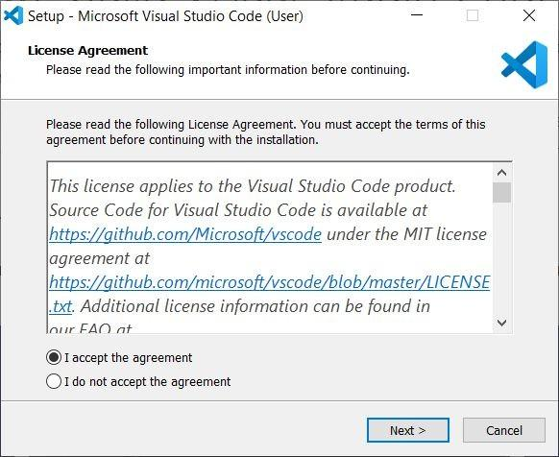

1. Set a *Destination Location* (default is fine)

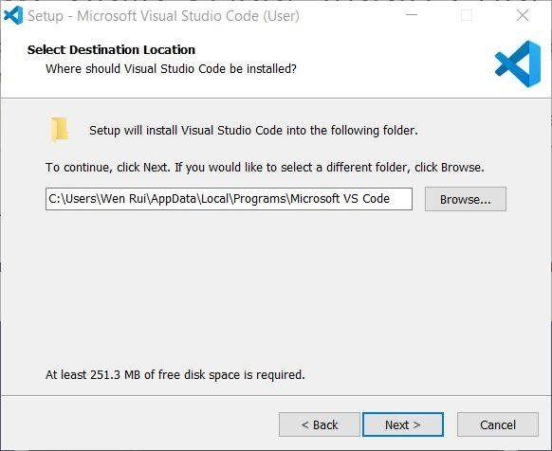

1. Create a *Start Menu Folder* (default is fine)

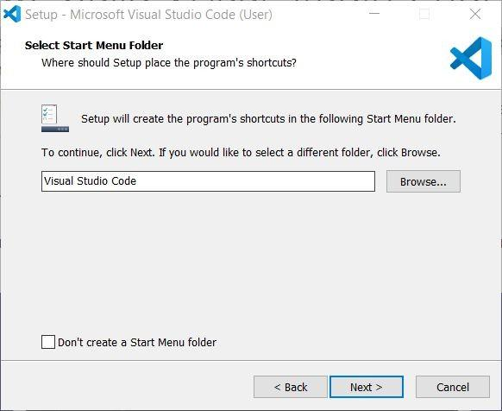

1. In the next screen, make sure that “Add to PATH” is selected

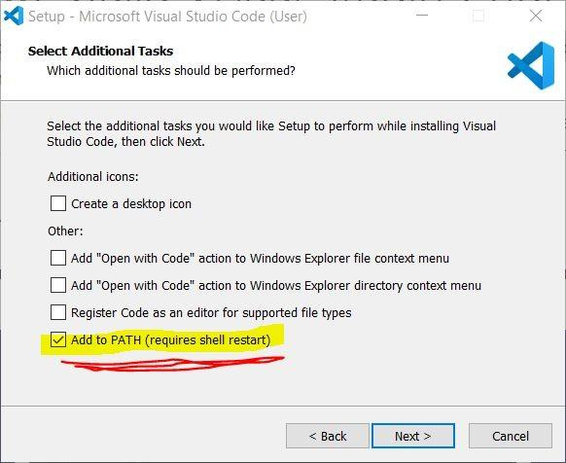

1. Press *Install*
2. Launch *Visual Studio Code* and go to Extensions (icon highlighted below, shortcut is Ctrl

+ Shift + X)

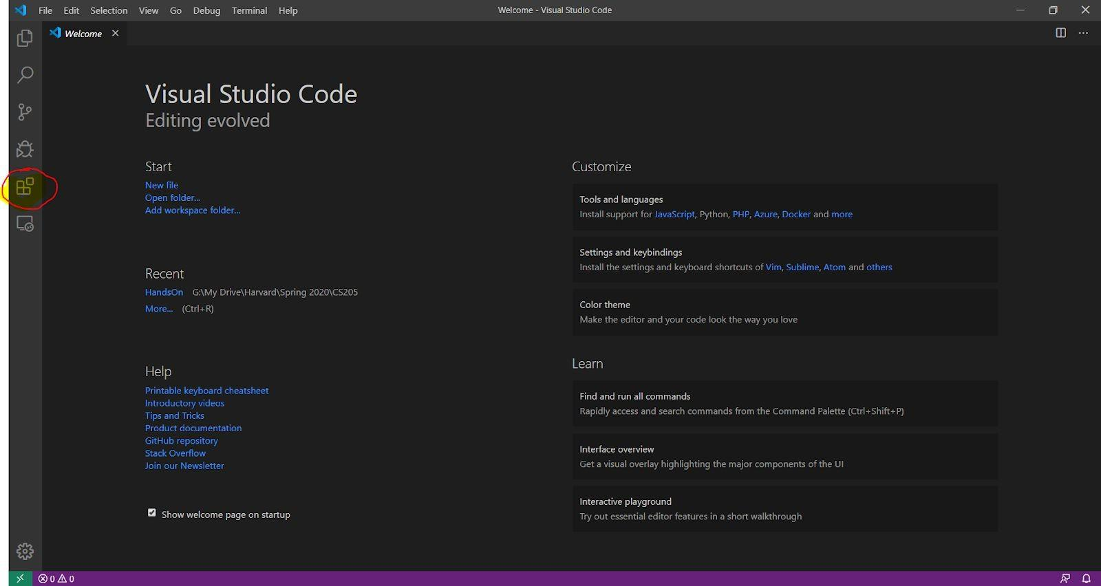

1. Search for **Python** in the search box and install the first result

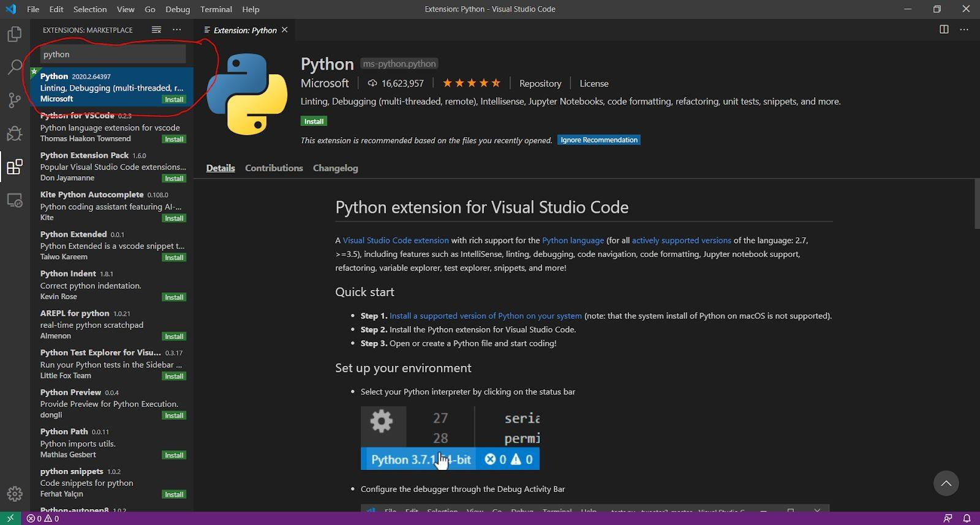

1. And that’s it, hopefully Python is installed! To test it out, let us store our [BasicPythonCode](https://uncg-my.sharepoint.com/:f:/g/personal/hoadegoke_uncg_edu/EuK3Ga1CQqNCsmVsUUV8pLQBv2obmfNJWDyKu732JwWQ5w?e=hQgix3) in a folder and open this folder at File > Open Folder.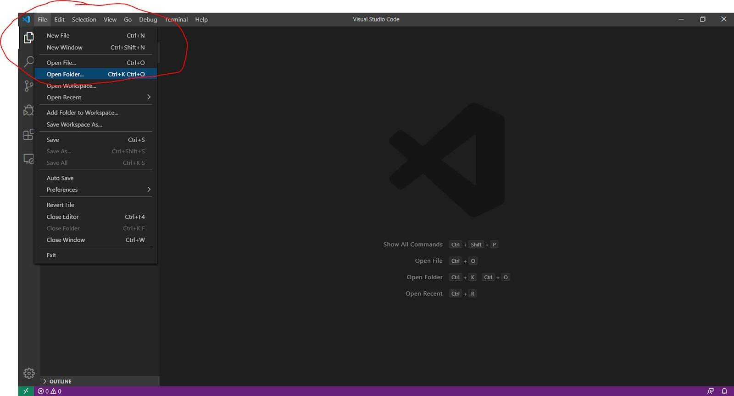
2. Open ***1.0-basic.ipynb***and you should see it pop up in the editor. Make sure that the Python 3.12.7 interpreter is selected in the top right corner of your screen.

1. There’s a lot happening on this screen which makes VSC powerful. On the bottom of the screen there is a terminal window that is pointing to the directory where the folder is located. You can run your familiar terminal commands here. Other windows here include an *Output* window and a *Debug Console*.



1. Moreover, we can run our code from within VSC (which makes it great). To check if everything is working, run the code with Debug > Start Debugging (Shortcut F5). If everything works, you should see the output in the terminal below!



1. Other extensions that you should install from the extension tab are;
   * GitHub Copilot
   * Jupyter
2. And that’s it! You now have a great tool for running Python files in this class.

**Mac:**

**Steps to install VSCode**

1. Go to this link (<https://code.visualstudio.com/docs/setup/mac)> and download Visual Studio Code for Mac.

a. Follow the instructions on this webpage under the section Installation.

🥳 At this point, you should successfully have VSCode on your Mac.

**Google Colab**

1. **Access Colab:** Go to <https://colab.research.google.com/> and sign in with your Google account.
2. **For the fine-tuning session, click 'Upload', then paste the '4.0 Fine Tuning.ipynb' file.**

**To Create a New Notebook:**

* + Click **"File"** in the top-left menu.
  + Select **"New notebook"**. This creates a new, untitled notebook saved automatically to your Google Drive.

1. **Rename Your Notebook:** Click on the default name (**"Untitled.ipynb"**) in the top-left corner and type a new, descriptive name.

**Connect to a Runtime:** When you first start or open a notebook, you may need to connect to a runtime (a virtual machine on Google's cloud) to execute code. Click the **"Connect"** button in the top-right corner if it's not already connected.

# Conclusion

VSC is great as it abstracts away a lot of the installation pains for Windows Users. Moreover, it allows you to live within this program for this training.

If you have any installation questions, feel free to ping me at [**hsmakinde@uncg**](mailto:hsmakinde@uncg.edu).edu